Task 1:

**import** org.testng.annotations.Test;  
  
  
**import static** org.junit.jupiter.api.Assertions.*assertEquals*;  
  
  
**public class** DemoTest001TestJunit {  
 @Test  
 **public void** Testcase1() {  
 String str = "Raghu";  
 *assertEquals*("Raghu", str);  
 }  
}

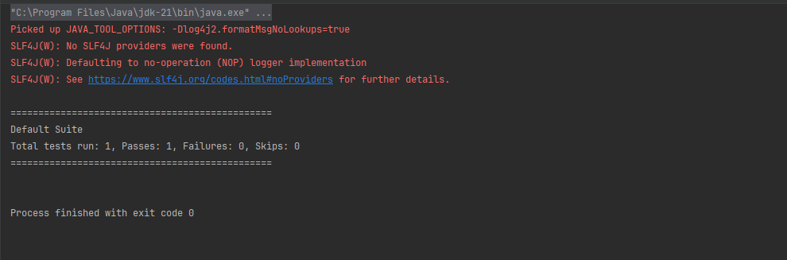

**import** org.testng.annotations.Test;  
  
  
**import static** org.junit.jupiter.api.Assertions.*assertEquals*;  
  
  
**public class** DemoTest001TestJunit {  
 @Test  
 **public void** Testcase1() {  
 String str = "Raghu";  
 *assertEquals*("raghu", str);  
 }  
}

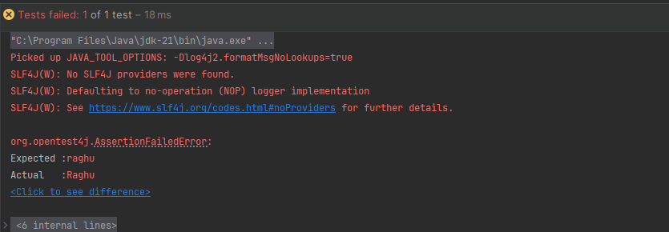

Task2:

**import** org.junit.jupiter.api.Test;  
**import** org.slf4j.Logger;  
**import** org.slf4j.LoggerFactory;  
  
  
**public class** DemoTest002TestJunitAssertions {  
 **private static final** Logger logger = LoggerFactory.getLogger(DemoTest002TestJunitAssertions.**class**);  
  
  
 @Test  
 **void** testcase01() {  
 logger.info("start testing");  
 String res = testcase02();  
 logger.info("testing is done "+res);  
 }  
 **private** String testcase02() {  
 logger.info(" we are in testcase02");  
  
  
 **try**{  
 Thread.sleep(1000);  
 }**catch**(InterruptedException ex) {  
 Thread.currentThread().interrupt();  
 logger.error("execution got interruped", ex);  
 }  
 **return** "success msg";  
 }  
}

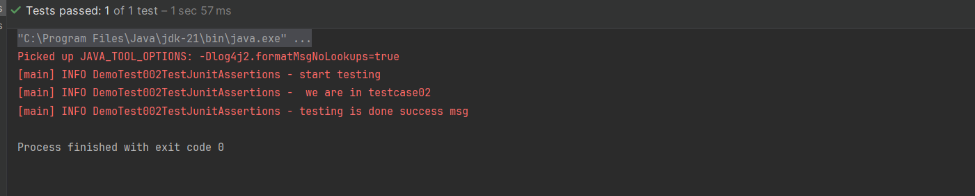

Task4:

**import** org.junit.jupiter.api.Assertions;  
**import** org.junit.jupiter.api.Assumptions;  
**import** org.junit.jupiter.api.Test;  
  
  
**public class** DemoTest004TestJunit5Assumptions {  
  
  
 @Test  
 **void** Testcase1() {  
 **boolean** condition = "true".equalsIgnoreCase(System.*getProperty*("runTest"));  
 Assumptions.*assumeTrue*(condition, "as the condition is not met skip test case");  
 **int** result = testcase2();  
 Assertions.*assertEquals*(10, result, "value need to be 10");  
 }  
  
  
 **private int** testcase2() {  
 **return** 10;  
 }  
}

